CommunityPoint iPhone® Application Check Sheet for Switchboard of Miami – SUMMER FOOD PROGRAM

# Customer Checklist

*Note: Since the APP is specific to each customer, it will not show up in the iPhone store until it is ready for the customer to access..*

**1) Application Name** (See Figure 1-1 for example)

* **App Name (on device**) (No more than 10 – 11 characters. No larger than icon.)

**BREAKSPOT**

* **App Name (on App Store) (**No more than 250 characters recommended)

**SUMMER BREAKSPOT FLORIDA**

**2) Application Description (**No more than700 characters recommended)

Please provide a paragraph description that you would like to see on the App store that tells about your community, service, etc.

**The SUMMER BREAKSPOT app lets you find locations in Florida where kids and teens 18 and under can get FREE NUTRITIOUS meals all summer long. For more information, visit www.SummerFoodFlorida.org or call 211.**

**3) Keywords**

Please list any key words that a search might bring up your App. (i.e. Name of organization, counties you serve, social services, etc.)

Bowman Systems will add a standard set of keywords applied to all *CommunityPoint* Applications: (*CommunityPoint*, 2-1-1, I&R, Information and Referral, Bowman Systems, and 211.)

**Free Food, Summer Food, Summer Food Program, USDA Summer Food Program, Summer BreakSpot, Miami, Miami-Dade, Florida, teens, kids**

**4) Icons (**See Figure 1-1 for an example. Figure 1-2 reflects how App will appear on iTunes store.)

Please supply a 512 x 512 pixel icon in 32-bit or 24-bit color .PNG (recommended) or .TIFF file format. (**Square edges only and no transparency**). Bowman Systems’ developers will scale the provided icon to various sizes needed throughout the application. To ensure the supplied icon will be clear in all sizes, **please test** the 512 x512 icon, by scaling to 57 x 57 pixels and reviewing, before sending (See note below)

*Note:* ***Files cannot be in JPEG or GIF format, nor can the images contain any transparency. The iPhone will automatically apply a glassy effect to the icons, so customers should not try to replicate this effect in their icon.***



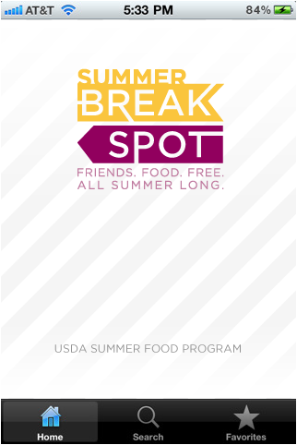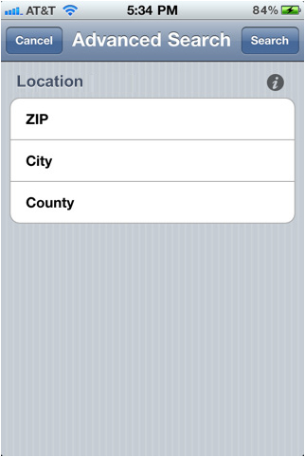

Figure 1-1